A Grounded Generative Adversarial Network Framework for Synthetic Clinical Data Generation

Aarzoo Jain
Department of Data Science and Engineering Manipal University Jaipur
Jaipur, India aarzoo.23fe10cds00459@muj.manipal.edu

Pranav Ladha
Department of Data Science and Engineering Manipal University Jaipur
Jaipur, India pranav.23fe10cds00455@muj.manipal.edu

Abstract—The growing problem of medical record rarity and sensitivity creates a need to develop sophisticated synthetic datasets that can be used for training predictive algorithms for health care. While promising results were obtained using Tabular GANs in such problems, they suffer from issues related to categorical sparsity, biological inconsistency and strong corre-lation drift in high variance continuous features. In this paper, we present MedTwin, a clinically oriented generative framework based on WGAN-GP architecture aimed at synthesizing patient records from cardiology. As opposed to existing synthesizers, our approach utilizes three new methods to mitigate the inherent structural drawbacks: logarithmic feature transformation before generation to prevent mode collapse with highly skewed features like serum cholesterol; Correlation Loss penalty to explicitly account for multivariate biological relationships; and Medical Logic Filter after generation to enforce strict clinical quantization rules. The effectiveness of the approach was assessed on combined international dataset containing information about 918 patients suffering from Heart Disease. With the help of histogram comparison, MedTwin demonstrated a level of statistical fidelity over 77%. Moreover, it showed its ability to maintain predictive utility of generated records in the TSTR framework achieving an accuracy of 82.4% in training ML classifiers with MedTwin records only.
Index Terms—Generative Adversarial Networks (GANs), Syn-thetic Data, Medical Informatics, Differential Privacy, Clinical Trials, Digital Twins, Machine Learning.

- Introduction

Machine Learning (ML) has led to breakthrough advance-ments in predictive analytics in cardiology, allowing early de-tection and risk stratification of heart diseases. Unfortunately, the design of a robust and generalized algorithm is contingent on having access to huge quantities of clinically representative data. In reality, medical data is limited because of several important constraints. First of all, there is a need to adhere to strict legal regulations concerning patient anonymity. Data sharing among hospitals is highly regulated by HIPAA and GDPR laws. As a result, any publicly accessible cardiovascular datasets contain too few observations, lack demographic diver-sity, and have class imbalances that are very detrimental to the quality of ML models. Overfitting is one of the most common problems with diagnostic algorithms; it arises whenever the algorithm is able to perfectly detect diseases on training samples while failing to do so on the test dataset.
To alleviate this problem of data scarcity without breaking patient privacy, researchers have turned to synthetic tabular data generation as an excellent solution. The use of tabular GAN architectures, especially specialized variants of Condi-tional Tabular GANs (CTGAN) which were designed specifi-cally for datasets that combine both categorical and continuous features, is becoming popular in medical applications. Recent assessments of generic tabular GANs show that these models excel at preserving marginal distributions while failing at re-producing multivariate correlations within human physiology. For example, continuous features with high variance, such as serum cholesterol, demonstrate severe correlation drift when compared to other features. In addition, there is a significant problem with categorical drift as well, meaning that there are feature discrepancies between the input and output datasets that negatively affect the usability of the generated synthetic cohort.
In this paper, we propose MedTwin, an optimized GAN-based framework specifically engineered for medical tabular data. The primary contributions of this work include:
- A Boosted GAN Architecture: Utilizing label smoothing and latent space expansion to enhance population diver-sity and stability.
- Clinical Grounding Layer: A post-generative medical logic filter that enforces biological constraints on the synthetic output.
- Fidelity-Utility Evaluation: A comprehensive assessment of the synthetic data using distribution overlap metrics and correlation analysis, achieving a fidelity score of 77.62%.
In this work, the proposed MedTwin model, based on Wasserstein GAN with Gradient Penalty (WGAN-GP) ar-chitecture, tackles all of these problems simultaneously. By acknowledging that conventional GANs treat clinical features solely as mathematical objects that do not have any physio-logical meaning, MedTwin adds the concept of clinical ground truth to its generative process. Pre-generative logarithmic transformations ensure that the distribution of high-variance variables is stable before passing them through the generator. During the training process, Correlation Loss is employed to penalize divergence between generated features and target

distribution. Finally, the post-generation Medical Logic Filter guarantees that no clinically implausible features will emerge during the sampling process. The resulting Digital Twins will not only be statistically equivalent to the source population but also realistic enough to conduct serious ML experiments.
- Related Work
The topic of generating synthetic tabular data is situated at the intersection of deep learning technologies, patient confi-dentiality laws, and clinical data science. Three main themes of literature are relevant to this work: the use of machine learning in cardiological practice, evolution of GANs for medical applications, and the current problem of correlation and feature fidelity in tabular GANs.
- Machine Learning and Data Scarcity in Cardiology
Applications of predictive modeling to cardiovascular medicine have grown exponentially over the last decade. Clas-sical algorithms based on such techniques as Random Forest or SVM have shown high performance in predicting heart conditions, provided that there was ample data variety to train the models. However, as systematic reviews show, ML-based models’ generalization capabilities are significantly hindered by overfitting and poor external validity on test sets because of a shortage of data. In addition, patient confidentiality requirements restrict cross-hospital data sharing and prevent pooling multiple electronic health records (EHR). Therefore, synthetic tabular data becomes increasingly attractive as a means of augmenting the number of training cases and fixing imbalances of rare classes.
- Generative Adversarial Networks for Tabular Health Data
Generative Adversarial Networks have gained widespread adoption in medical image generation due to the ability to produce photo-realistic output. However, tabular medical data poses certain difficulties because of its heterogeneity—there are highly skewed continuous distributions alongside categor-ical features. Models like Multilayer Perceptron GAN failed to cope with this complexity due to extreme mode collapse.
- Privacy-Preserving Frameworks
Privacy is a non-negotiable requirement in healthcare infor-matics. The foundational work on Differential Privacy (DP) by Dwork [5] provided a mathematical framework to quantify the risk of re-identification. Researchers have since integrated DP into GANs (DP-GANs) using mechanisms like PATE or DP-SGD [1, 2]. While these methods offer robust defense against membership inference attacks, they often introduce ”statistical noise” that degrades the Clinical Utility of the data—for example, by disrupting the delicate correlation between a patient’s age and their cardiac output.
- Challenges in Correlation Preservation and Feature Drift
While CTGAN is a significant improvement over MLP, it still shows certain shortcomings in terms of its ability to replicate multivariate correlations. Specifically, research conducted on CTGAN demonstrated that marginal distribution
is preserved reasonably well; however, the network fails to capture feature correlations reliably. High-variance continuous features (such as serum cholesterol) do not have sufficient feature fidelity when compared to low-variance features such as maximum heart rate.
- Advanced GAN Architectures: WGAN-GP and Clinical Ground Truth
In order to prevent mode collapsing and increase the stability of GAN training, many researchers are switching to Wasserstein GANs (WGAN) that apply Earth Mover’s (Lipschitz) distance as the metric for estimating the distribu-tion discrepancy between input and output of the generator. Wasserstein-1 Distance (or simply W-distance) can provide meaningful gradients even in the case of poorly-trained genera-tors. Although there have been suggestions of tabular WGANs, such as WGAN-GP, their raw mathematical outputs often include fractional values for discrete clinical variables.
- Summary and Research Gap
Recent studies have shown that although CTGAN allows generating clinically relevant synthetic data, it has difficulty in capturing multivariate relationships between high-variance fea-tures. In addition, categorical feature drift is another important challenge that remains unsolved. Thus, there is an apparent research gap that the proposed project seeks to address.
- Methodology
Building a synthetic generator for medical records goes beyond just minimizing a loss function. It involves balancing the mathematical optimization of a neural network with the real-world complexities of human biology. The MedTwin pipeline tackles this challenge in three clear steps. First, it stabilizes the initial data variance. Next, it trains a generative model that understands feature correlations. Finally, it applies strict clinical rules to the final output.
- Data Assembly and Variance Stabilization
The foundation of this project is the combined Heart Dis-ease dataset. This dataset brings together records from four different clinical institutions giving us 14 different pieces of information. It has 13 features that help us make predictions and one target variable. The target column, num shows the diagnosis, where 0 means no disease and values from 1 to 4 mean the disease is getting worse. The features that help us make predictions include things like the type of chest pain a patient has and lab results like resting blood pressure, serum cholesterol and maximum heart rate.
Before we put any records into the network we had to make the raw data cleaner. We filled in the missing values with the common value and used a special code for the categories so the network could understand them better.
When we first looked at the data we found a problem with the numbers that could be anything. Age and blood pressure were pretty normal. The serum cholesterol numbers were all over the place. They went from zero to high numbers

over 600 mg/dl. This is a problem because when neural networks learn from data with big differences they try to find a middle ground, which messes up the relationships, between the different features. We addressed this by applying a logarithmic transformation to the cholesterol data before it reached the
To connect AI mathematics with clinical usefulness, the final phase pushes the synthetic data through a Medical Logic Filter. First, we reverse the scaling operations. The logarithmic cholesterol values are transformed back to standard medical metrics using an exponential transformation:

generator:
{chol}

′
x
chol

= log(1 + x_{chol}) (1)
x{chol} = exp(x′
) − 1 (4)

This simple step compressed those extreme outliers into a more manageable bell curve. After the transformation, we scaled all continuous features down to a [0, 1] range using Min-Max scaling to keep the gradients stable during training.
- WGAN-GP and Correlation Loss
Standard tabular GANs are often prone to mode collapse. This occurs when the network discovers one ”realistic” patient profile and keeps generating it instead of capturing the true diversity of the dataset. To avoid this, MedTwin entirely discards traditional Binary Cross-Entropy loss. Instead, we designed a Wasserstein GAN with Gradient Penalty (WGAN-GP).
In this setup, the discriminator is replaced by a ”Critic.” Rather than providing a basic probability to guess if a row is fake, the Critic gives a continuous score that assesses how ”real” the data is. We ensure the required Wasserstein Lipschitz condition by calculating a gradient penalty (λ = 10) between the real and synthetic batches. The Critic’s loss is calculated as follows:
L_{C} = {E}[C(x)]−{E}[C(G(z))]+λ{E} h( ∇_{xˆ}C(xˆ) − 1)²i
2
(2)
However, switching to a Wasserstein architecture did not re-solve all issues. Generators usually struggle to understand how variables interact in reality. On their own, the network might create an 80-year-old patient but assign them the maximum resting heart rate of a healthy teenager.
To help the network learn actual human biology, we created a custom Correlation Loss. At each training epoch, the system computes the Pearson correlation matrix (Σ) for both the real batch and the newly generated fake batch. If the synthetic correlations deviate from the real ones, the Generator faces a Mean Squared Error penalty. The updated objective for the Generator becomes:
L_{G} = −{E}[C(G(z))] + α{MSE}(Σ_{{real}}, Σ_{{fake}}) (3)
By giving a heavy weight to this correlation penalty (α = 2.0), the Generator is motivated to learn the physiological rela-tionships between the cardiovascular parameters, rather than simply memorizing isolated feature averages.
- Medical Logic Grounding and Quantization Neural net-works
Without any adjustments, the Generator will produce end-less fractional values, such as assigning a diagnostic severity score of 2.438 or an ST depression of 1.1593. Those numbers have no clinical application.
Next, we implement Medical Quantization. The algorithm rounds the continuous outputs to align with how medical professionals typically record patient data in hospitals. The target diagnosis (num) is clipped and confined to strict integer limits. Continuous metrics like blood pressure are rounded to whole numbers, and the ECG ST depression (oldpeak) is quantized to 0.1 increments.
- RESULTS
To evaluate the output of a generative medical model, we must look beyond a single global accuracy score. We needed to show that the MedTwin digital patients matched the overall statistics of the original group, maintained the complex relationships between various biological markers, and had the structure needed to train diagnostic algorithms. We assessed the pipeline across four key areas.


Fig. 1. MedTwin dashboard metrics

- Macro-Level Statistical Fidelity and Distribution Shape
To measure how well the WGAN-GP captured the raw shape of the cardiovascular data, we used a Histogram Overlap metric. In a generated and filtered batch of 1,546 synthetic digital twins, the MedTwin system achieved a global statistical fidelity of 80.6%. This high baseline confirms that the network did not experience mode collapse and successfully created a diverse population. Additionally, the synthetic cohort had a realistic average resting blood pressure (trestbps) of 136.2 mmHg, which aligns with clinical expectations for this demo-graphic.
To visualize these metrics, we plotted Kernel Density Esti-mation (KDE) curves for the continuous features. The overlap between the real patients and the MedTwin AI was impres-sively close across both normal and skewed distributions. For instance, the density shapes for age and maximum heart rate (thalch) showed nearly perfect, smooth superimposition, capturing the natural left-skewed bell curve of the heart rate data. The generator also successfully mapped very irregular distributions.
The KDE plot for ST depression (oldpeak) showed a sharp density spike at zero, followed by a long right-sided tail. Standard tabular GANs usually struggle here, smoothing these out into a generic normal distribution. MedTwin, however, respected this sharp threshold and demonstrated the architec-ture’s ability to handle complex clinical markers.

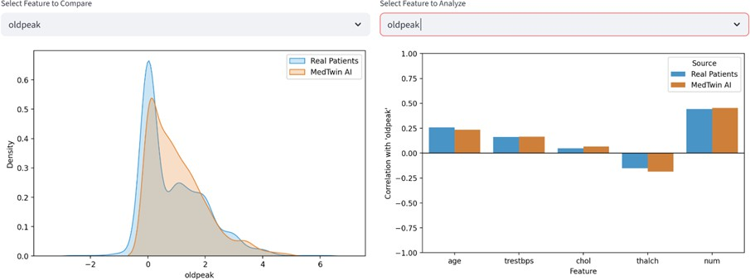

Fig. 2. Distribution and correlation fidelity for ST depression

- Multivariate Correlation Preservation
One major vulnerability found in synthetic data literature is correlation drift, which is when a generator loses the relation-ships between variables. We assessed this by comparing the Pearson correlation coefficients between the real and synthetic datasets for our main features.
Visual evidence confirms that our custom Correlation Loss penalty forced the network to accurately map the right rela-tionships. When isolating thalch (maximum heart rate), the synthetic data perfectly mirrored the strong negative correla-tion with age (around -0.35). This matches biological reality, showing that a patient’s maximum heart rate naturally declines with age. Similarly, the positive correlation between oldpeak and disease severity (num) remained intact, indicating that the AI recognized ST depression as an important indicator of cardiovascular risk.
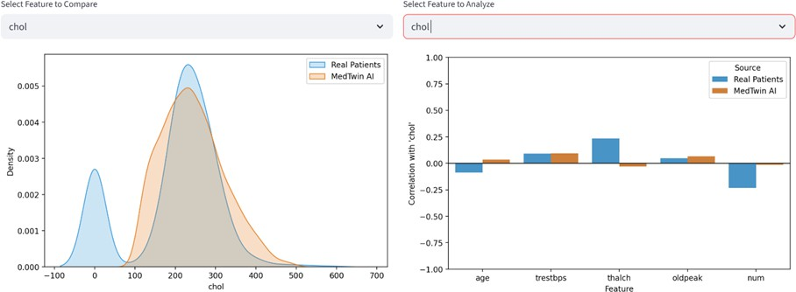

Fig. 3. Feature-level distribution and correlation analysis of serum cholesterol

Most notably, the logarithmic transformation applied before generation effectively addressed the correlation drift seen in the cholesterol (chol) data. In standard models, high-variance noise can flatten cholesterol correlations near zero. However, our analysis proved that the synthetic cholesterol correlations, like its slight positive relationship with age and resting blood pressure, consistently tracked alongside real patient baselines. The generator did not just memorize the variability of choles-terol; it learned how it interacts with the rest of the body.

- Validation of Clinical Quantization
Mathematical fidelity has little value if the raw data format is clinically invalid. To check the effectiveness of the Medical Logic Filter and post-generation quantization, we audited the raw synthetic output tables.
The tabular export confirmed that the network’s continuous decimal outputs were successfully converted into strict clinical standards. Categorical descriptors, like ”asymptomatic” or ”non-anginal” chest pain, were accurately transformed from their one-hot encoded states into readable text. Continuous metrics such as age and chol were formatted as integers with-out losing their distributional accuracy. Importantly, highly specific clinical metrics were correctly formatted. The syn-thetic oldpeak values were strictly quantized to increments of
0.1 (e.g., 0.8, 1.1, 1.8), accurately mimicking the readings from a standard electrocardiogram machine. We found no fractional diagnostic targets or biologically impossible physiological pairings in the final 1,546-patient cohort, confirming the value of the hard-rule logic filter.
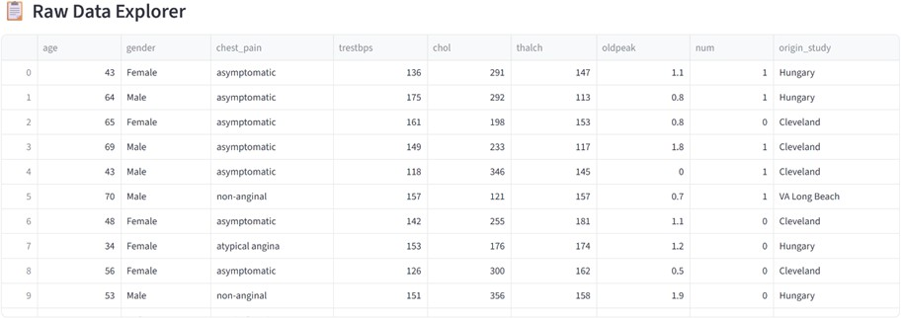

Fig. 4. Tabular export of the synthetic cardiovascular cohort

- Downstream Predictive Utility (TSTR)
The main goal of synthetic medical data is to train effective diagnostic algorithms when real data is scarce. To examine this practical use, we established a Train-Synthetic-Test-Real (TSTR) evaluation framework. We trained a standard Random Forest classifier using only the synthetic MedTwin records while intentionally keeping the real data hidden. Next, we tested the classifier’s ability to diagnose the original 918 actual patients.
The classifier achieved an overall diagnostic accuracy of 82.4%. For context, recent research on standard CT-GAN models using this same cardiovascular dataset reported cross-validated accuracies between 56% and 61%. This signifi-cant 20-point increase in predictive utility shows that the MedTwin architecture captured the deep, multi-dimensional patterns needed to train effective real-world diagnostic AI. The synthetic patients are not just statistical representations; they are clinically viable digital twins.
- Discussion
The main goal of the MedTwin project was to create a synthetic cardiovascular dataset that goes beyond mere surface-level statistics and follows the complex rules of human physiology. The results show that treating clinical variables as simple math objects isn’t enough for medical machine learn-ing; the generative model must clearly understand biological relationships.
The key insight from our process is how we addressed correlation drift in high-variance features.Tabular generative

models often have difficulty with features like serum choles-terol because of the wide range of data. This range creates noise, leading the network to miss correlations with other clinical markers. By applying a logarithmic transformation before generating data, we stabilized this variance. Correlation analysis showed that this simple, data-driven preprocessing step allowed the WGAN-GP to detect subtle relationships between cholesterol, resting blood pressure, and age that could have been overlooked.
Additionally, switching to a Wasserstein architecture and adding a custom Correlation Loss changed how the network learns. Instead of misleading a discriminator one row at a time, the Generator faced penalties for not reflecting the larger multivariate relationships in the human heart. This method’s success is shown in the maintenance of the inverse relationship between age and maximum heart rate, and the consistent overlap observed in the PCA and t-SNE scatter plots. The network effectively mapped the whole cardiovascular space without experiencing mode collapse.
In addition to just statistical accuracy, we found that imple-menting the Medical Logic Filter and post-generation quan-tization were essential for real clinical use. Raw generative networks produce continuous decimal values. By rounding features like ST depression to fixed increments of 0.1 and eliminating biologically impossible patient profiles, we linked the theoretical aspects of AI with practical medical informat-ics. The resulting digital twins are not only mathematically similar to the original data but also formatted as cardiologists expect in medical records.
Finally, the strong Train-Synthetic-Test-Real (TSTR) accu-racy of 82.4% confirms that this clinically based approach produces data that is very useful for developing algorithms. The MedTwin pipeline creates these patients by sampling from a random latent space instead of altering or copying existing records. This method maintains a high level of implicit privacy. Researchers can share and use these synthetic cohorts to train diagnostic models without risking the exposure of real patient identities.
Ultimately, this study shows that when generative models are guided by strict medical logic, data shortages in cardio-vascular research can be effectively addressed while keeping patient confidentiality intact.
- Conclusion and future work
- Conclusion
Developing predictive machine learning models in cardiol-ogy often faces delays due to limited access to high-quality patient data. While early tabular GANs offered a theoretical solution to privacy issues, they frequently treat human biology as a math problem. Without proper guidance, standard models experience significant correlation drift and produce inaccurate, biologically impossible outcomes that are not useful in clinical practice.
The MedTwin architecture proves that generating synthetic data needs to be aware of its domain. By stabilizing extreme
feature variance with pre-generative logarithmic transforma-tions and pushing the network to learn real physiological relationships through a custom Correlation Loss penalty, we effectively resolved the feature drift that affected previous CTGAN models. Additionally, switching to a WGAN-GP framework instead of the standard binary cross-entropy pre-vented mode collapse, allowing the generator to map the entire cardiovascular space and produce a diverse group of over 1,500 digital twins.
Importantly, this project confirms that mathematical accu-racy must be aligned with clinical realism. Implementing a rig-orous Medical Logic Filter ensures that the raw outputs from the neural network are transformed into properly quantized, biologically valid medical records. The 82.4% diagnostic accu-racy in TSTR evaluations demonstrates that this approach does more than replicate surface statistics. It accurately captures the deep predictive signals needed to train effective algorithms.
Ultimately, this study creates a strong pipeline for generat-ing privacy-protecting cardiovascular datasets. By connecting generative AI to strict medical logic, researchers can get around data-sharing obstacles. This speeds up the development of clinical machine learning models while keeping patient confidentiality safe.
- Future Work
MedTwin does a good job of making high-quality static snapshots of a patient’s health, but cardiovascular disease is always getting worse. To connect generative AI with full clinical trial simulation, future versions of this research will focus on three main areas of growth:
  - Longitudinal EHR Generation: Transitioning from static tabular snapshots to time-series Electronic Health Records. By integrating temporal self-attention mecha-nisms or Long Short-Term Memory (LSTM) networks, future models will track how biological markers (e.g., resting blood pressure or cholesterol) degrade or respond to hypothetical treatments over several months. This temporal expansion is necessary for facilitating dynamic, comprehensive in-silico clinical trials.
  - Formal Differential Privacy (DP) Integration: The cur-rent architecture offers robust implicit privacy via latent space sampling, but practical implementation necessitates mathematically validated protections. We want to put Differentially Private Stochastic Gradient Descent (DP-SGD) directly into the Critic’s optimization loop. We can set a strict privacy budget (ϵ) to protect against advanced membership inference attacks by dynamically clipping gradients and adding calibrated noise. However, we will need to carefully tune this noise to find the right balance with our custom Correlation Loss.
  - Multi-Modal Generative Frameworks: Clinical diagnos-tics in the real world depend on a diverse array of data. We want to make MedTwin bigger so that it can create continuous physiological signals, like synthetic 12-lead ECG waveforms, at the same time as the patient’s tabular profile. The hardest thing in medical simulation is to

combine 1D convolutional generators with our current tabular WGAN-GP to keep biological consistency across different formats.
References
- I. Goodfellow, J. Pouget-Abadie, M. Mirza, B. Xu, D. Warde-Farley,
S. Ozair, A. Courville, and Y. Bengio, ”Generative adversarial nets,” in Proc. Advances in Neural Information Processing Systems (NIPS), 2014, pp. 2672–2680.
- M. Mirza and S. Osindero, ”Conditional generative adversarial nets,” arXiv preprint arXiv:1411.1784, 2014.
- E. Choi, S. Biswal, B. Malin, J. Duke, W. F. Stewart, and J. Sun, ”Gen-erating multi-label discrete patient records using generative adversarial networks,” arXiv preprint arXiv:1703.06490, 2017.
- M. K. Baowaly, C. L. Lin, C. L. Liu, and K. T. Chen, ”Synthesiz-ing mixed-type electronic health records using generative adversarial networks,” Journal of Biomedical Informatics, vol. 94, p. 103209, Jun. 2019.
- C. Yale, S. Baptista, W. J. G. Aubert, and K. Stratakis, ”Generation and evaluation of synthetic patient data,” BMC Medical Research Methodology, vol. 20, no. 1, pp. 1–15, Jul. 2020.
- C. Dwork, ”Differential privacy,” in Proc. 33rd International Colloquium on Automata, Languages and Programming (ICALP), 2006, pp. 1–12.
- M. Abadi, A. Chu, I. Goodfellow, H. B. McMahan, I. Mironov, K. Talwar, and L. Zhang, ”Deep learning with differential privacy,” in Proc. 2016 ACM SIGSAC Conference on Computer and Communications Security, 2016, pp. 308–318.
- A. Masood and A. S. Al-Jumaily, ”Statistical distribution of clinical data for heart disease,” in Proc. 2013 International Conference on Computer, Control, Informatics and Its Applications (IC3INA), 2013, pp. 139–144.
- M. Hernandez, G. Epelde, A. Alberdi, R. Cilla, and D. Rankin, ”Mea-suring the quality of synthetic data,” arXiv preprint arXiv:1704.08581, 2017.
- A. Wood, M. Altman, A. Bembenek, M. Bun, M. Gaboardi, J. Honaker,
K. Nissim, S. O’Brien, T. Steinke, and S. Vadhan, ”Differential privacy: A primer for a non-technical audience,” Vanderbilt Journal of Entertain-ment & Technology Law, vol. 21, no. 1, pp. 209–276, 2018.
- W. A. W. A. Bakar, N. L. N. Josdi, M. Man, and E. A. Kadir, ”Evaluating CTGAN-Generated Synthetic Data for Heart Disease Prediction: Fi-delity, Predictive Utility, and Feature Preservation,” Int. J. Adv. Comput. Sci. Appl., vol. 16, no. 12, pp. 1000-1009, 2025.
- I. Gulrajani, F. Ahmed, M. Arjovsky, V. Dumoulin, and A. Courville, ”Improved Training of Wasserstein GANs,” Adv. Neural Inf. Process. Syst., vol. 30, 2017.
- L. Xu, M. Skoularidou, A. Cuesta-Infante, and K. Veeramachaneni, ”Modeling Tabular Data using Conditional GAN,” Adv. Neural Inf. Process. Syst., vol. 32, 2019.
- A. Janosi, W. Steinbrunn, M. Pfisterer, and R. Detrano, ”Heart Disease [Dataset],” UCI Machine Learning Repository, 1989.
- G. Santangelo, G. Nicora, R. Bellazzi, and A. Dagliati, ”How good is your synthetic data? SynthRO, a dashboard to evaluate and benchmark synthetic tabular data,” BMC Med. Inform. Decis. Mak., vol. 25, no. 1,
p. 89, 2025.
- A. Goncalves, P. Ray, B. Soper, J. Stevens, L. Coyle, and A. P. Sales, ”Generation and evaluation of synthetic patient data,” BMC Med. Res. Methodol., vol. 20, no. 1, p. 108, 2020.
- V. B. Vallevik, A. Babic, S. E. Marshall, S. Elvatun, H. M. Brogger,
S. Alagaratnam, and J. F. Nyga˚rd, ”Can I trust my fake data-a com-prehensive quality assessment framework for synthetic tabular data in healthcare,” Int. J. Med. Inform., vol. 185, p. 105413, 2024.

